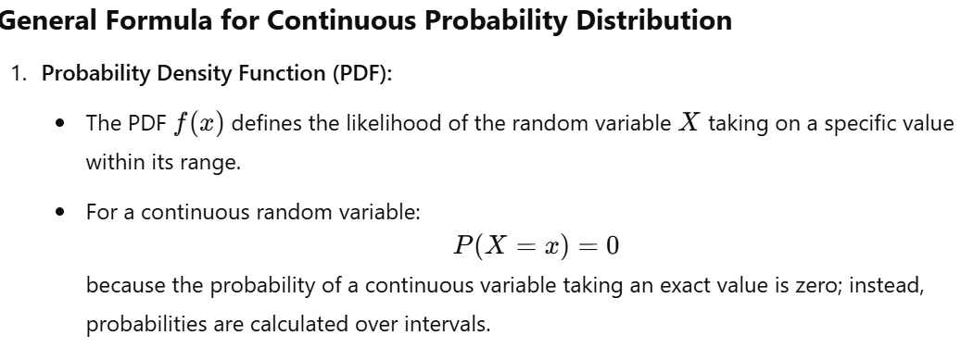
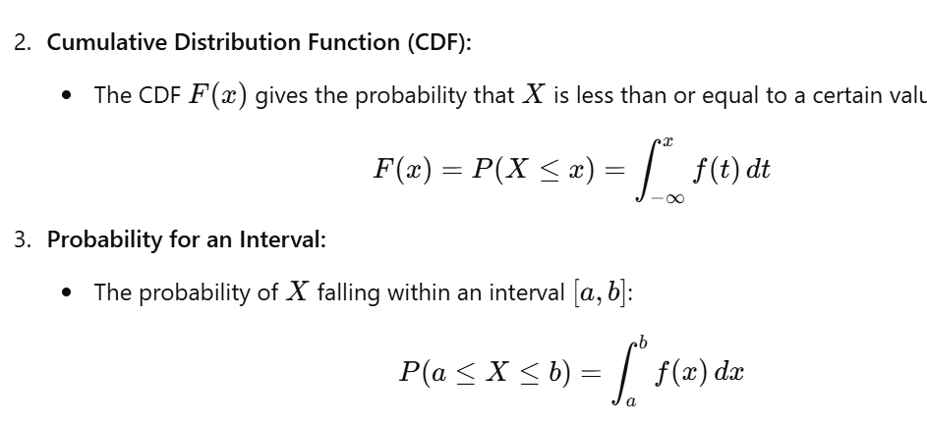
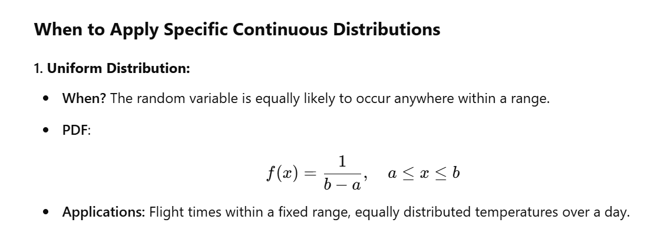

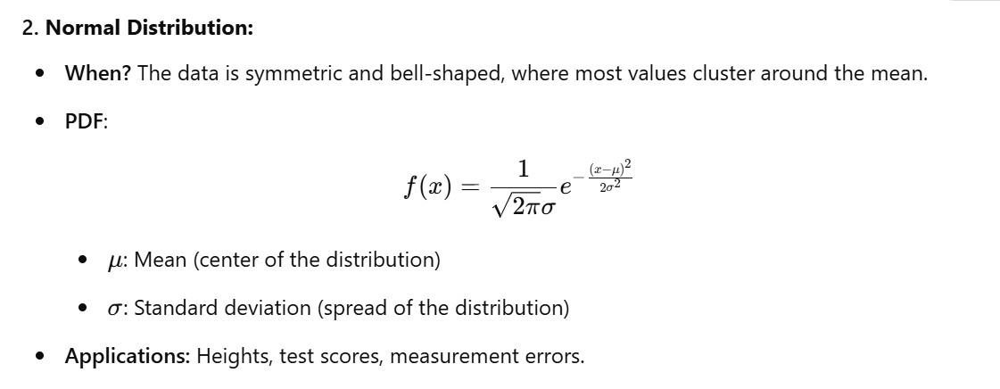

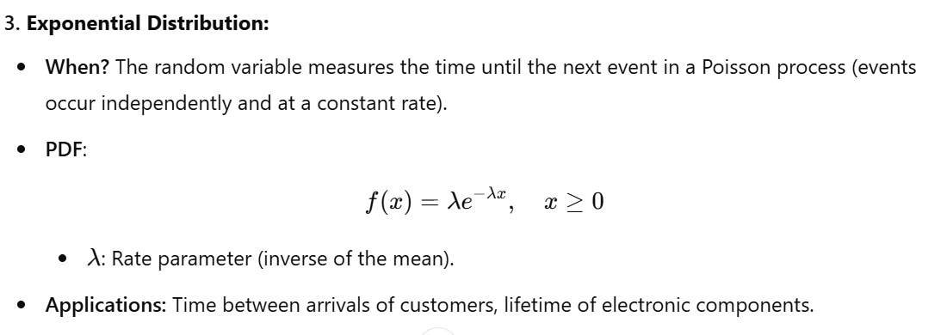

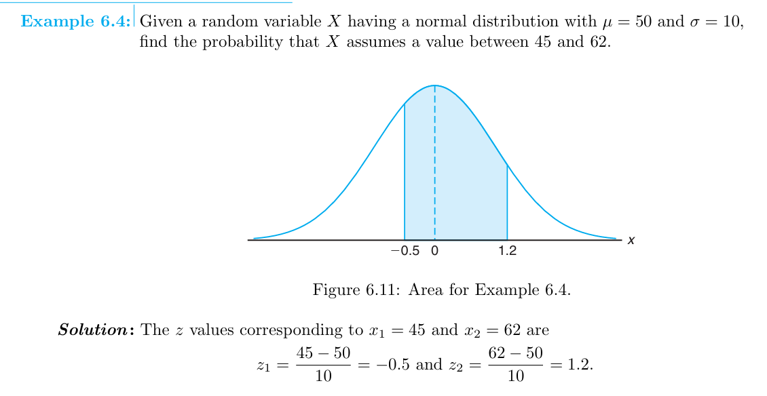

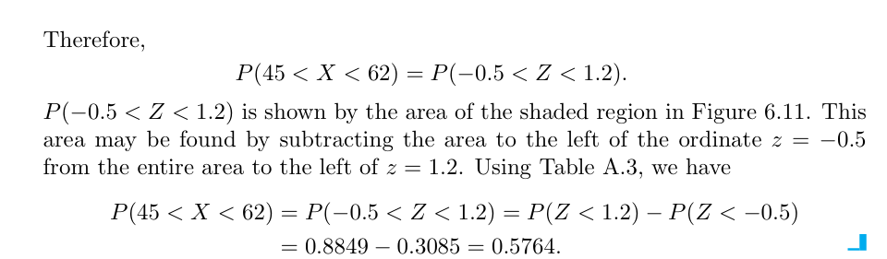

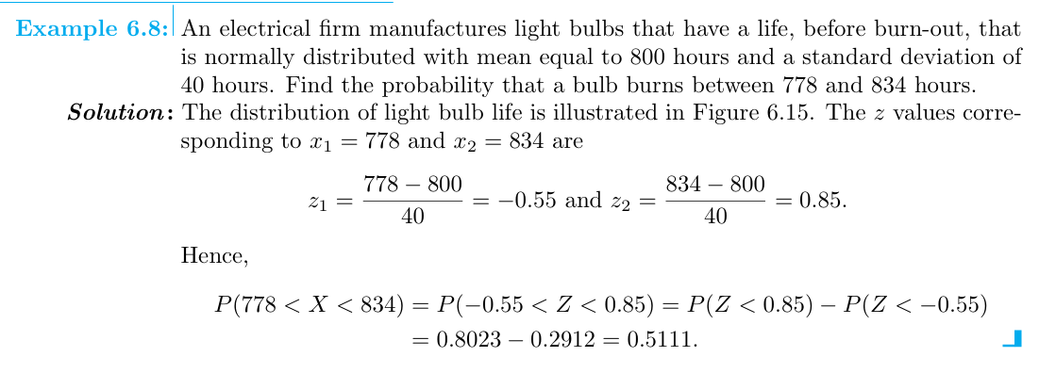

where we let X be the flight time in minutes of an airplane traveling from Chicago to New York and the sample space of X is between 120 and 140 minutes this means the flight may arrive anytime between 120 and 140 minutes the flight time is equally likely to be any time within that interval and the flight time cannot be any time outside that range.

- calculate the probability that the flight time will be between 120 and 130 minute.
- calculate the probability that the flight time will be between 125 and 150 minute.
- calculate the 75th percentile.
- Calculate expected mean & variance.

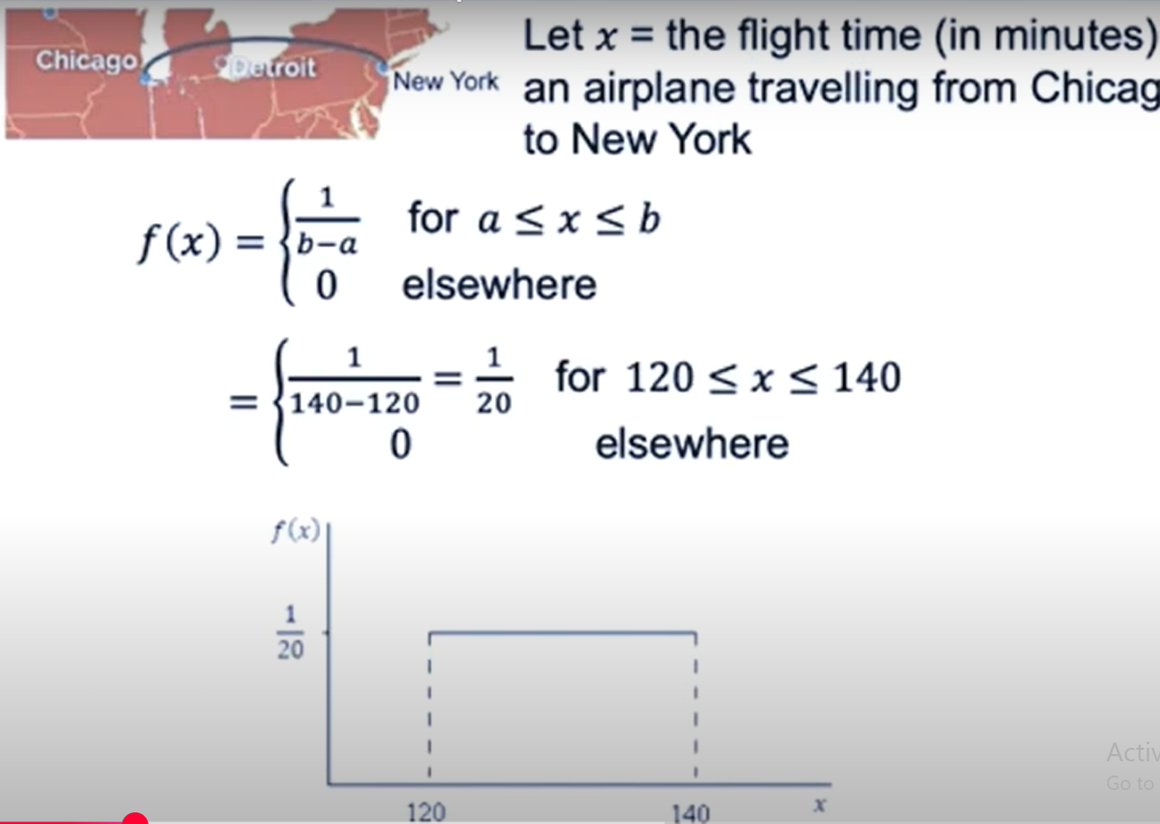
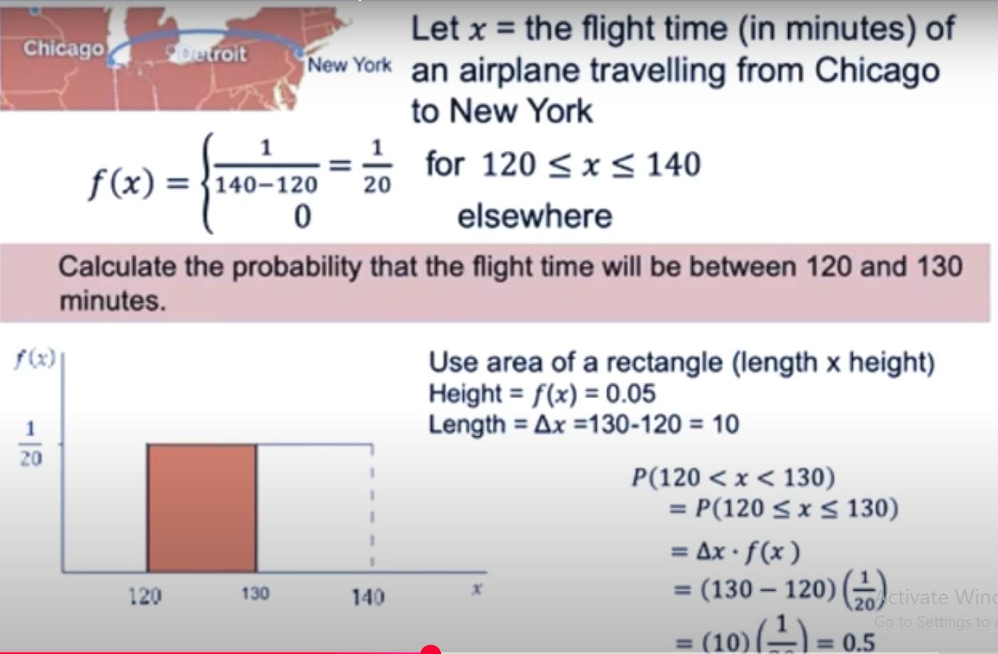

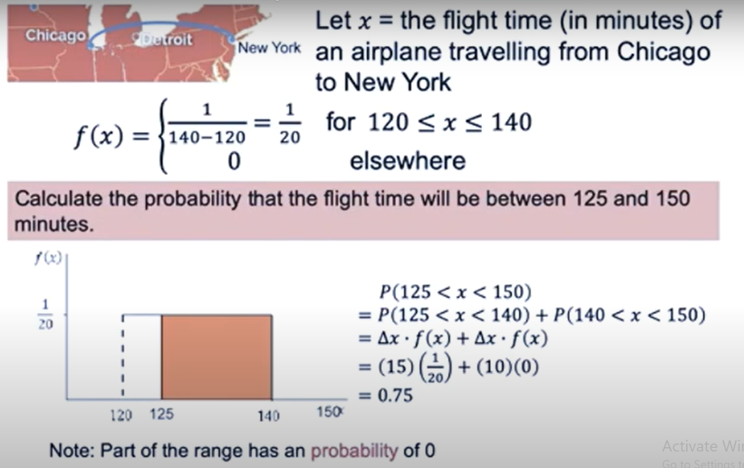
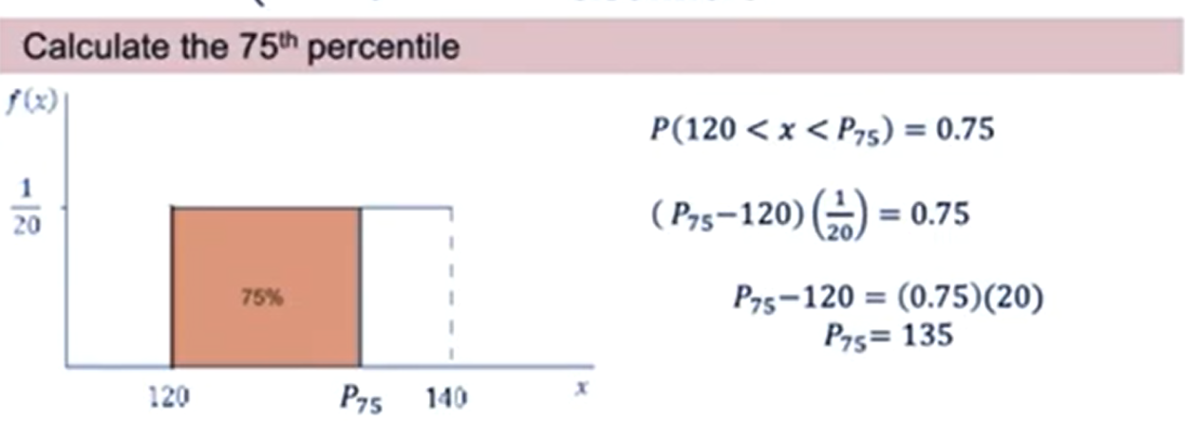
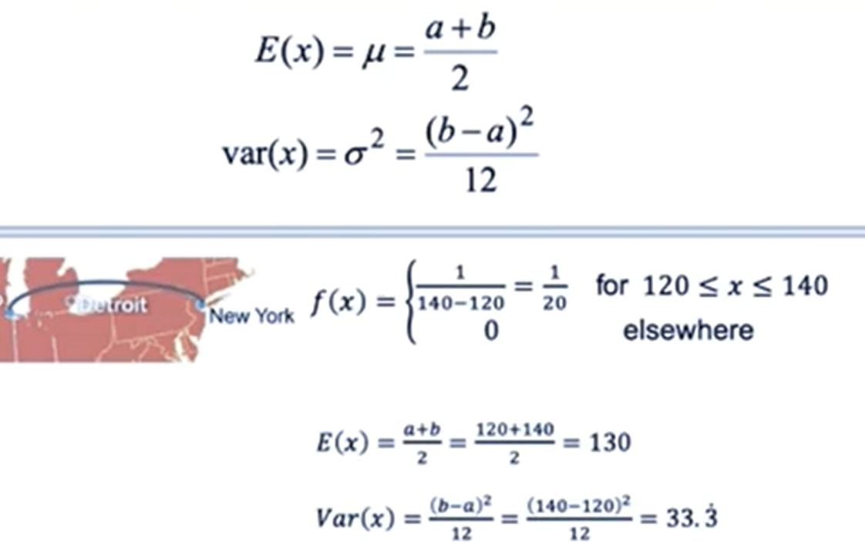
• What is hypothesis testing, and what have you learned about its application?
• Explain how hypothesis testing is used in computer science with relevant examples.

What is Hypothesis Testing, and What Have You Learned About Its Application?
Hypothesis testing is a statistical method used to determine whether there is enough evidence in a sample to support or reject a claim about a population parameter. It involves comparing observed data to a theoretical assumption (null hypothesis) to check for statistical significance.
- Key Steps in Hypothesis Testing:
  - Formulate the null hypothesis (H0​) and the alternative hypothesis (H1​).
  - Choose the appropriate test statistic (e.g., z-test, t-test, chi-square).
  - Compute the test statistic from the sample data.
  - Compare the test statistic with the critical value at a given significance level (α\alphaα).
  - Make a decision: Reject or fail to reject ​.
What I learned:
Hypothesis testing provides a structured framework to make data-driven decisions and validate claims with statistical evidence.

2. How is Hypothesis Testing Used in Computer Science?
Hypothesis testing is widely used in computer science to validate models, compare algorithms, and improve system performance. Some common applications include:
- Algorithm Performance Comparison:
  - Example: Test whether Algorithm A has a faster runtime than Algorithm B.
  - Approach: Use a t-test to compare the mean runtimes of the two algorithms.
- A/B Testing in Software Development:
  - Example: Test whether a new webpage layout (A) results in higher click-through rates than the old layout (B).
  - Approach: Use a proportion z-test to analyze user behavior.
- Machine Learning Model Validation:
  - Example: Test whether a new machine learning model performs better than a baseline model.
  - Approach: Use paired t-tests to compare the models’ accuracies on test data.
- Network Traffic Analysis:
  - Example: Test whether the observed traffic pattern matches the expected behavior to detect anomalies.
  - Approach: Use a chi-square goodness-of-fit test.
- Human-Computer Interaction (HCI):
  - Example: Test whether users prefer a new interface design over the old one.
  - Approach: Collect survey data and apply a chi-square test for user preferences.
- Error Rate Analysis in Systems:
  - Example: Test if a new server configuration reduces the error rate below 1%.
  - Approach: Use a one-sample proportion test.
Conclusion:
Hypothesis testing allows computer scientists to make informed decisions, optimize processes, and ensure robust system performance based on statistical evidence.

QUESTION a random sample 100 recorded that in the United State during the past year show average life spent 71.8 assuming a population standard deviation of 8.9 does the same to indicate the mean life span spend today is greater than 70 year use? 0.05 use a Label of significance (the table value 0.9783).

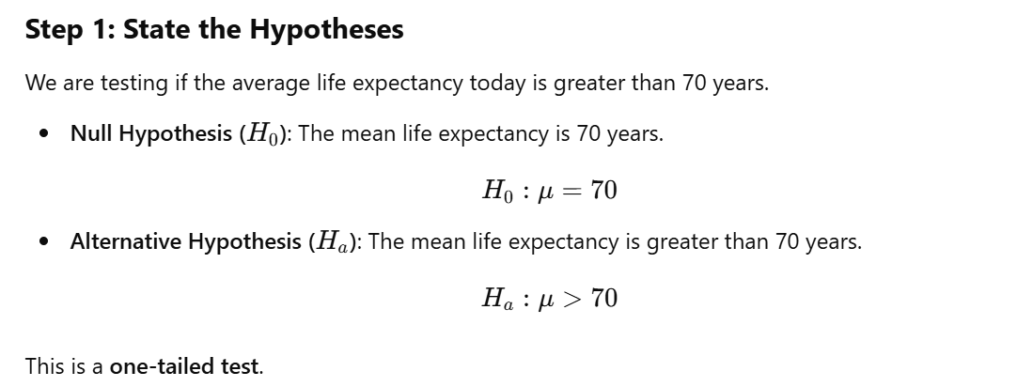
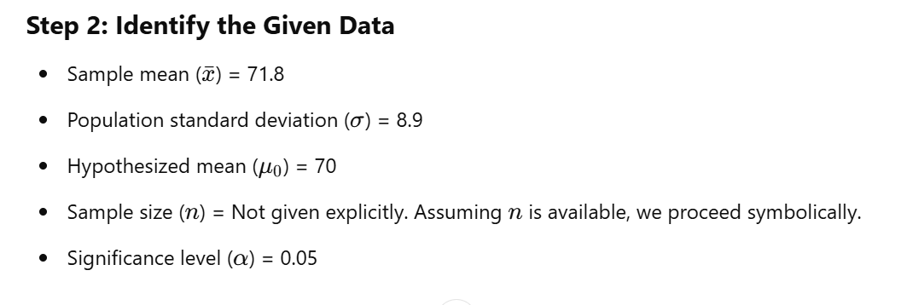
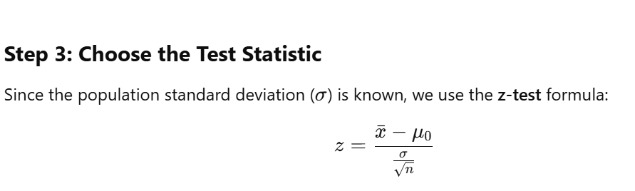
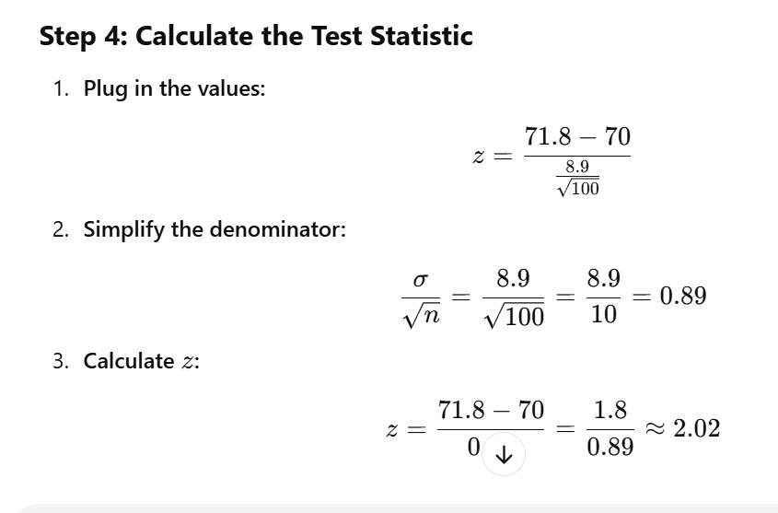
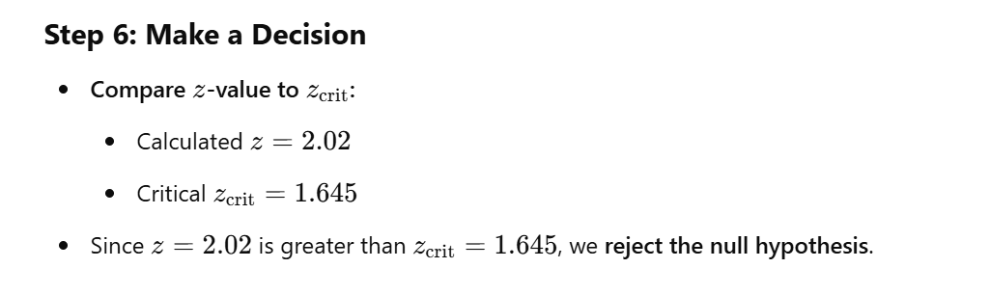

Chi-Square Goodness-of-Fit Test: Explanation
The chi-square goodness-of-fit test is a statistical method used to determine whether a set of observed data matches a theoretical or expected distribution. It is commonly applied in scenarios where you want to assess whether a categorical variable follows a specified distribution.

Purpose of the Test
The test helps to answer the question:
- Does the observed data fit the expected distribution?
For example:
- Is a die fair (each face equally likely)?
- Are preferences for different brands as expected?
- Does a coin toss produce equal probabilities of heads and tails?
